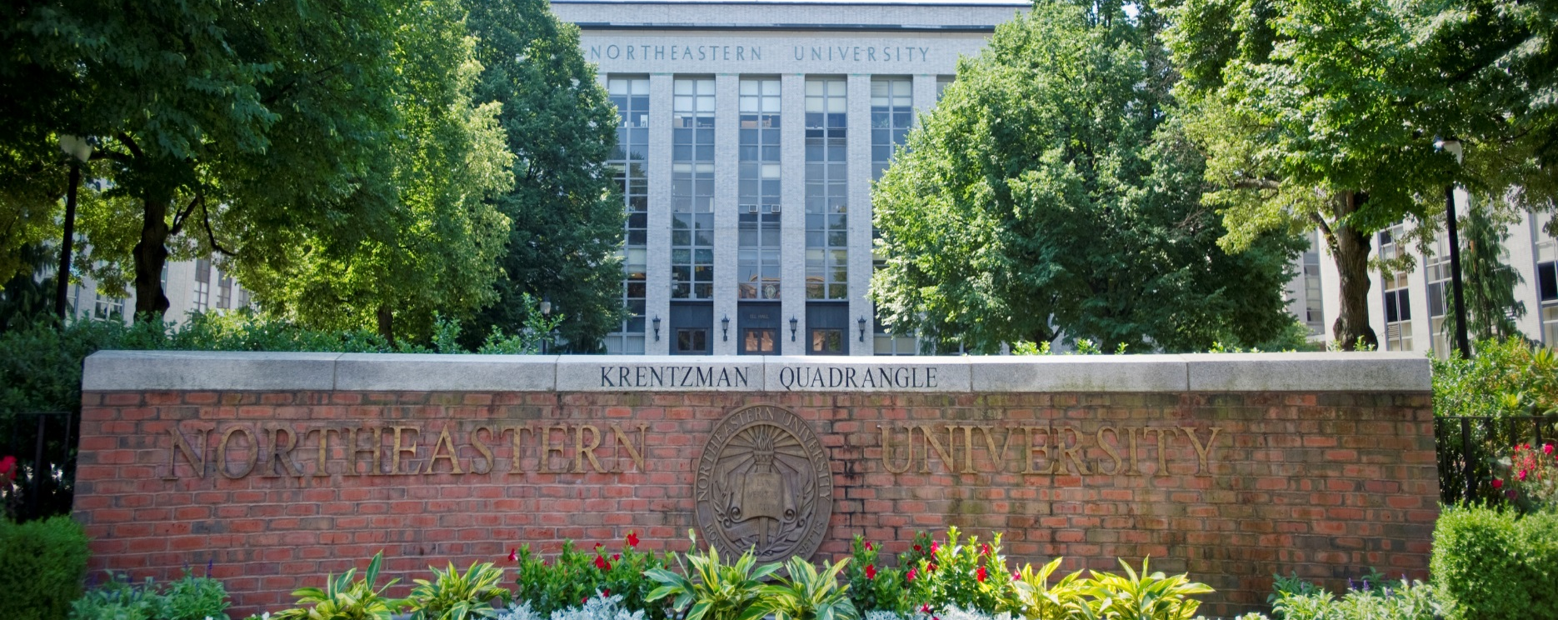

DISTINGUISHED SEMINAR

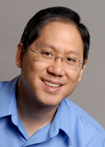

Clark T.-C. Nguyen
University of California at Berkeley
Berkeley Sensor & Actuator Center (BSAC)

Mechanical Circuit-Enabled Micro-Scale Radios
Wednesday, December 11
140 ISEC
1:30 pm


Department of
Electrical and Computer Engineering

Abstract:
The use of mechanics to lower the dynamic range requirements of radio and clock receivers has recently reduced low-bit-rate communication receive power consumption to near-zero levels and stands poised to enable radio cognition for more efficient use of high-bit-rate spectrum. Approaches to cognition and power reduction go from partial-mechanical ones, where low-capacitance integration of high Q mechanical circuits with transistors provides finer spectrum parsing to ease the burden on transistor circuits; to the latest all-mechanical topology, where micromechanical resonant switch (a.k.a., resoswitch) technology enables listening for incoming signals without the need for current draw, and ultimately only picowatts to receive and process bits once valid signals appear.

Bio:
Prof. Clark Nguyen is a Professor in the Electrical Engineering and Computer Sciences Department at the University of California at Berkeley, where his main research thrust focuses on micromechanical signal processing. He is the Founder of Discera; served from 2002 to 2005 as a Program Manager in DARPA/MTO; and recently finished a term as President of the IEEE Ultrasonics, Ferroelectrics, and Frequency Control Society. He is an IEEE Fellow and recipient of the 2006 IEEE Cady Award and the 2017 IEEE Bosch MEMS Award.

